Springboard Virtual Internship 6.0
Name : K Jithendar Reddy
College : KL University
Branch : CSE
Domain : Data Visualization
Project : Visualizing US Natural Disaster Declarations
Mentor : G.K.S. Jyoteesh
Date : 1/4/2026

Milestone-4 Documentation: Incident Type Analysis

1. Objective
The objective of this milestone is to analyze the distribution of disaster incident types across the United States and integrate insights from previous milestones.

This analysis helps in understanding:
- Which disaster types occur most frequently
- How disaster types vary across states
- The relationship between disaster types and assistance programs
This milestone focuses on identifying patterns and drawing meaningful conclusions from disaster data.

2. Problem Formulation
Analysis Type:
- Incident Type Analysis
- Exploratory Data Analysis (EDA)
Key Questions:
1. Which disaster types are most common?
2. Which states experience specific disaster types the most?
3. How are assistance programs related to incident types?
4. What insights can be derived by combining all milestones?

3. Dataset Preparation
Input Dataset:
usnd_cleaned.csv
Required Columns:
- incidentType
- state
- year
- month
- ihProgramDeclared
- paProgramDeclared

Data Validation Steps:
- Ensure no missing values in key columns
- Verify consistency of incident types
- Confirm dataset integrity from previous milestones

4. Incident Type Aggregation
The dataset is grouped by incidentType to calculate total disaster occurrences.
Purpose:
- Identify most frequent disaster types
- Understand distribution of disasters
State + Incident Type Aggregation:
Group dataset by state and incidentType
Purpose:
- Identify dominant disaster types in each state

5. Core Visualizations
5.1 Incident Type Distribution Chart
Bar chart showing frequency of each disaster type.
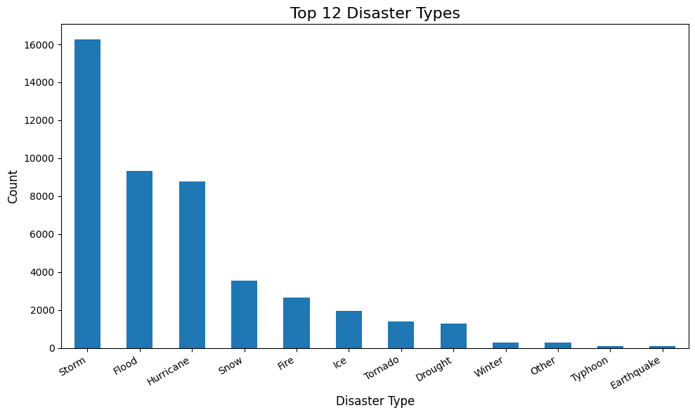
5.2 State vs Incident Type Heatmap
Heatmap showing disaster counts across states and types.
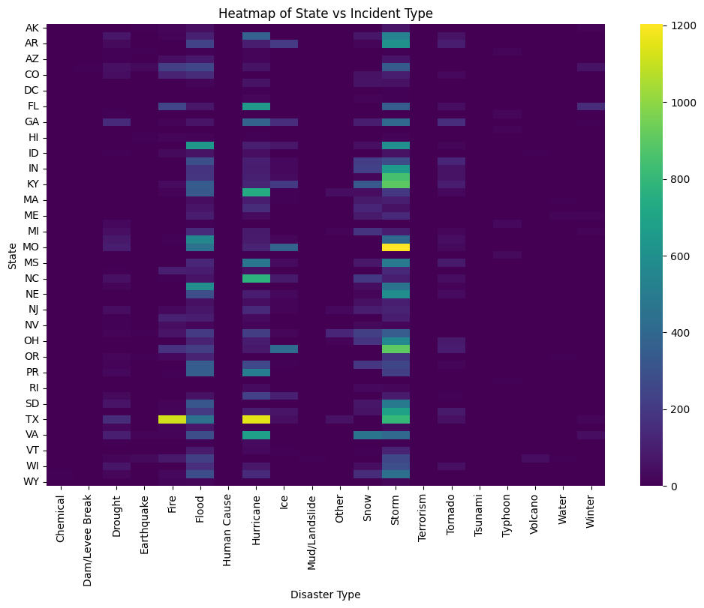
5.3 Stacked Bar Chart
Shows contribution of each disaster type within states.

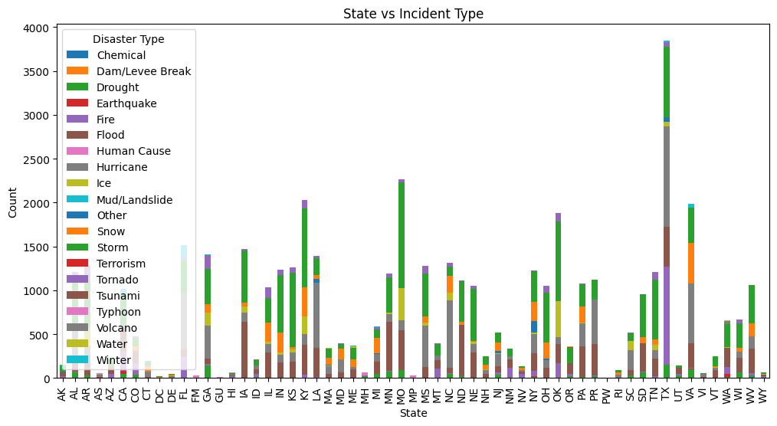
5.4 Assistance Program Comparison
Grouped bar chart comparing IH and PA programs across incident types.
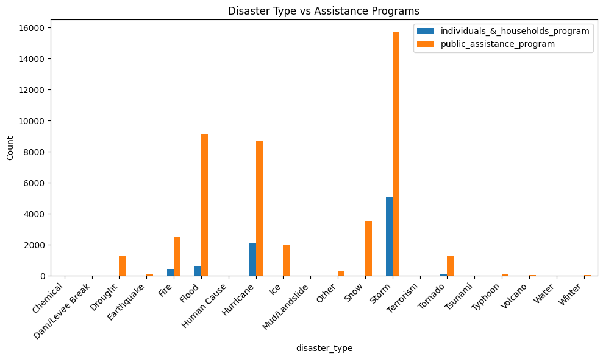

6. Assistance Program Analysis
Analyzes relationship between:
- incidentType
- ihProgramDeclared
- paProgramDeclared

Insights:
- Severe disasters trigger both assistance programs
- Public assistance is more frequent in infrastructure-related disasters

7. Cross-Milestone Insights
Milestone-1:
- Cleaned dataset improves reliability
Milestone-2:
- Disaster frequency increases over time
- Seasonal patterns observed
Milestone-3:
- Certain states are disaster-prone
- Geographic hotspots identified
Milestone-4:
- Few disaster types dominate
- Strong link between geography and disaster type

8. Tools and Libraries Used
Data Processing:
- Pandas
- NumPy
Visualization:
- Matplotlib
- Seaborn
Analysis Platform:
- Jupyter Notebook

9. Visualization Standards
Mandatory Elements:
- Title
- Axis Labels
- Legend
- Proper Color Scale

Best Practices:
- Use readable colors
- Avoid clutter
- Highlight key insights

10. Conclusion
The Incident Type Analysis successfully identified patterns in disaster occurrences across the United States.
By combining insights from temporal, geographic, and incident analysis:
- Frequent disaster types were identified
- State-specific patterns were observed
- Assistance program behavior was analyzed

This provides a comprehensive understanding of disaster trends and supports better decision-making.

